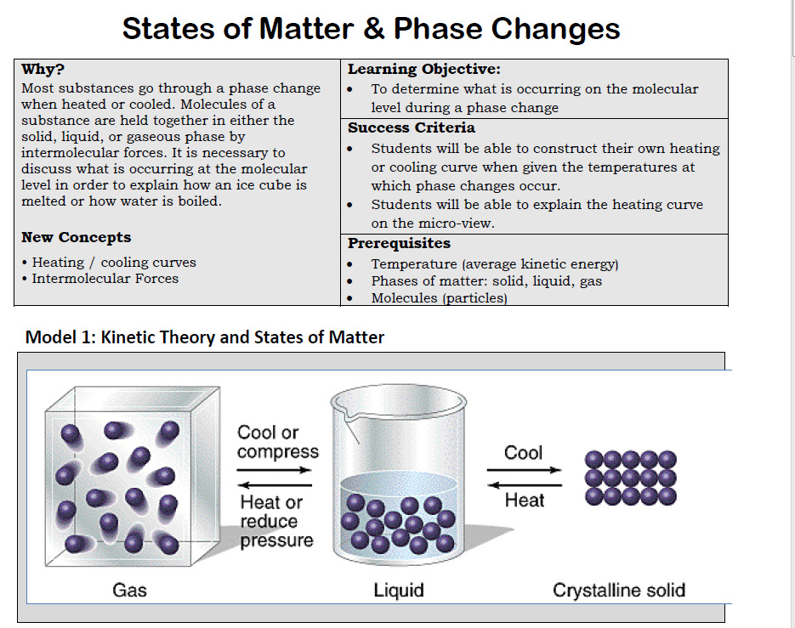
- What are the key characteristics of atoms and molecules in gases, liquids, and solids? In table 2 below, describe the characteristics of particles for each phase of matter based on Model 1 above. Be specific with regard to spacing of particles, the potential of particles for movement, and whether or not the particles will fill the containers.
 | Solid | Liquid | Gas
Spacing
Motion of the particles
Filling a container
- In which phase of matter is there the least spacing between particles? ______________________________
- In which phase of matter is there the most potential for movement? ______________________________
- Which phase of matter does not have a definite shape yet the particles will not fill the container? ______________________________
- What would be necessary to change from a solid to a liquid? What is this change called and how is this accomplished in terms of temperature and kinetic energy (of the molecules)?

- What would be necessary to change a liquid to a gas? What is this change called and how is this accomplished in terms of temperature and kinetic energy (of the molecules)?

- What would be necessary to change a liquid to a solid? What is this change called and how is this accomplished in terms of temperature and kinetic energy (of the molecules)?

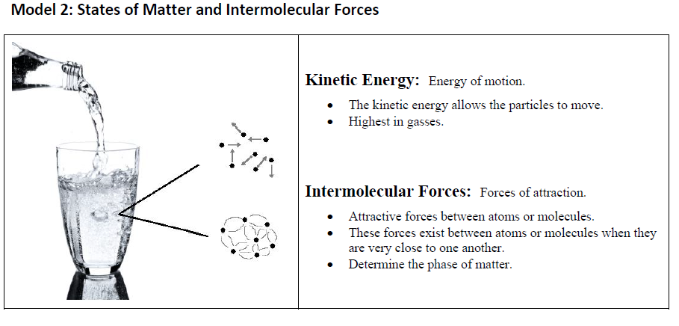
- In your own words, explain what intermolecular forces are:

- Similar to magnets, it takes ____________________ energy to move atoms that have stronger attractive forces.
- Intermolecular forces are (stronger/weaker) when particles are closer together.
- Rank the states of matter (high, medium, low) for each of the two categories below. Include a brief explanation.
 | Solid | Liquid | Gas
Kinetic Energy of Particles
Intermolecular Forces

- Look at your descriptions for the spacing, movement, and ability to fill a container in Table 2. Are they consistent with what you now know about intermolecular forces? Explain why or why not, and revise any discrepancies.

Model 3 Phase Changes
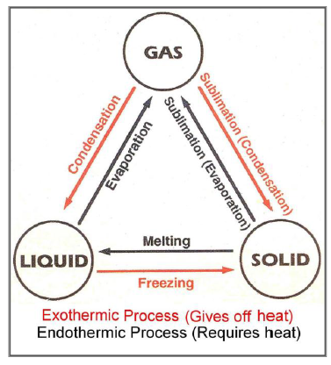
- Which arrows in model 3 require the addition of energy?

- Which term, endothermic or exothermic, is used to describe the situation when energy is added into a system from the surroundings?

- Which phase changes are endothermic?

- Which arrows in Model 3 indicate the release of energy?

- Which term, endothermic or exothermic, is used to describe the situation when energy is released into the surroundings by the system?

- Which phase changes are exothermic?

Complete the table below about phase changes.
